02.10 SUBSEQUENT EVENTS WORK PROGRAM

The following describes the functionality and features included in Probe Audit Premium+

Objective

The objective of this document is to guide the engagement team through the procedures required to identify and evaluate subsequent events occurring between the date of the financial statements and the date of the auditor's report, and to document the conclusions reached.

The following key concepts of the Probe Audit Premium+ Methodology are set in this document:
- Identification of events between the financial statement date and audit report date (ISA 560)
- Evaluation of whether identified events require adjustment or disclosure in the financial statements
- Impact of subsequent events on the audit opinion and audit report date

Document placement

Document 02.10 – Subsequent events work program can be found in the Finalisation folder in the Caseware document manager.
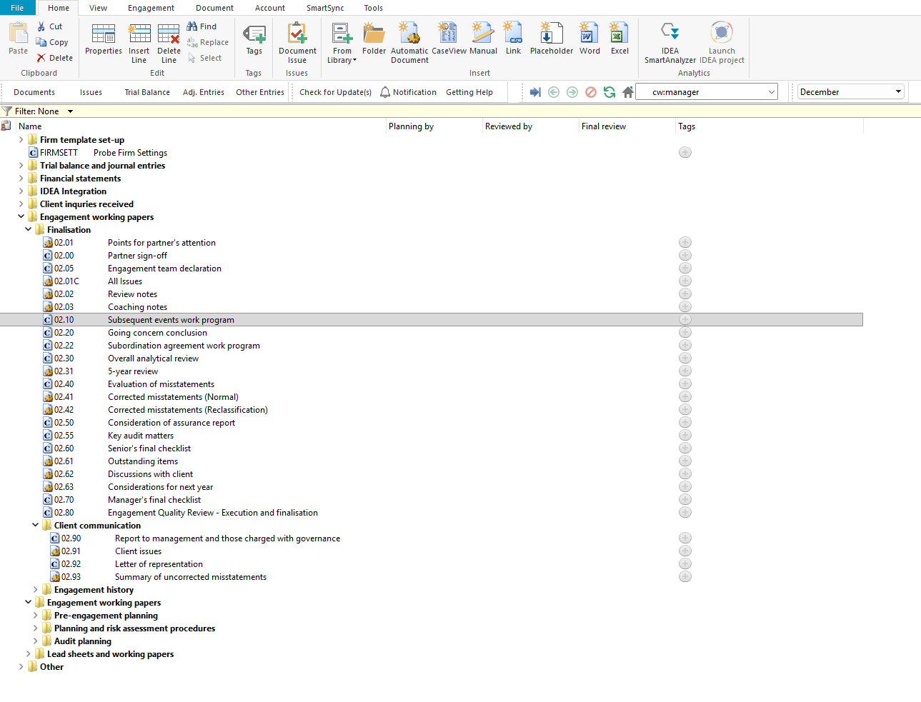

Document content

This document is designed to be a CaseView work program with pre-populated audit procedures and space for comments, event recording, and cross-referencing.

This document addresses ISA 560 (Subsequent Events) by providing a structured set of procedures for identifying events occurring between the date of the financial statements and the date of the auditor's report. The procedures also reference the IFRS for SMEs Accounting Standard Section 32 (Events after the End of the Reporting Period) as issued by the International Accounting Standards Board.

This document is divided into different bookmarks in the document map to assist you with navigation:

Procedures to identify events

Conclusion
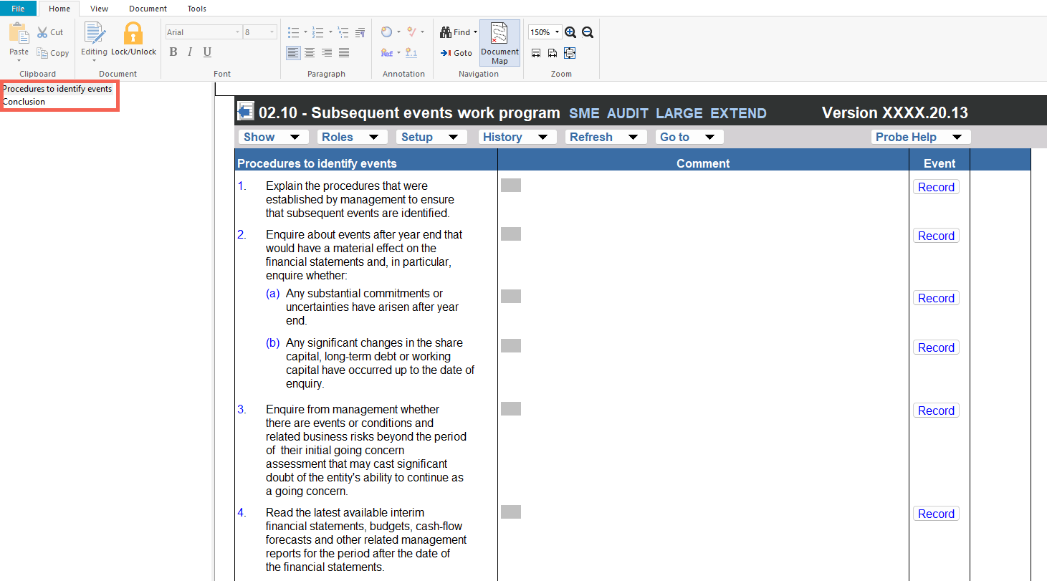

Layout
Column | Input Required | Outcome
Procedures to identify events
Procedures to identify events | No input is required in this column. Displays 11 numbered audit procedures for identifying subsequent events. These procedures address management enquiries, review of interim financial information, reading of minutes, obtaining written representations, enquiries of legal counsel, and review of adjusting and non-adjusting events in accordance with the IFRS for SMEs Section 32. | No impact on the engagement file. Provides the structured work program for the engagement team to perform subsequent events procedures.
Comment | Enter comments or further detail describing the work performed and findings for each procedure. | No impact on the engagement file. Documents the engagement team's comments and findings for each subsequent events procedure.
Event | Enter a description of any subsequent event identified during the performance of the procedure. | No impact on the engagement file. Records the subsequent event identified for the engagement file.
Ref. | Enter a cross-reference to the relevant working paper or supporting documentation for each procedure. | No impact on the engagement file. Documents the cross-reference for the engagement file.
Conclusion
Conclusion statement | No input is required in this column. Displays the pre-populated conclusion: "No subsequent events were identified that need to be recorded in the financial statements." | No impact on the engagement file. Provides the default conclusion for the engagement team's review.
Comment | Enter any comments relating to the conclusion on subsequent events. | No impact on the engagement file. Documents the engagement team's comment on the conclusion for the engagement file.

Document outcomes

The engagement team must perform the 11 subsequent events procedures and document their comments, events identified, and cross-references for each procedure performed. The procedures cover management enquiries regarding events after year end, review of interim financial information, obtaining written representations, enquiries of legal counsel, and evaluation of adjusting and non-adjusting events in accordance with the IFRS for SMEs Section 32.

The engagement team must review the pre-populated conclusion and confirm that no subsequent events were identified that need to be recorded in the financial statements, or amend the conclusion where subsequent events have been identified.

Group Audits

When the engagement type was selected as 'Group Audit Single' or 'Group Audit Multiple', the subsequent events work program applies to the group engagement. The engagement team must perform the subsequent events procedures for the group financial statements and consider the impact of subsequent events at both the group and component level.

IN CONCLUSION

Features

The following features are available in the document:

Insert or delete a comment, see page F3

Insert or delete a row at the end, see page F5

Guidance, see page F16

Freeze, see page F19

